
JABIIBE TAILOR MANAGEMENT SYSTEM
GAROWE-PUNTLAND-SOMALIA

ABDI WARSAME JAMA
EAUG00012454

BY
ABDIRAHMAN ISHAK MOHAMUD
EAUGRW0003753

DECLARATION
I, hereby declare that this project entitled “JABIIBE Tailor Management System” is my original work and has not been submitted to any other institution for academic award.

Name: Abdirahman Ishak Mohamud
Signature: _____________________________
Date: ____ / ____/__________
APPROVAL
This project entitled “JABIIBE Tailor Management System” has been submitted for examination with my approval as the academic supervisor.

Supervisor: Sead Habeeb
Signature: ______________________________
Date: ____ / ____/__________
DEDICATION

I dedicate this project to my family, teachers, and friends for their continuous support, encouragement, and motivation throughout my studies.
ACKNOWLEDGEMENT

First, I thank Almighty Allah for giving me the strength and ability to complete this project. I sincerely thank my supervisor, Sead Habeeb, for his guidance, advice, and support. I also appreciate my family, lecturers, classmates, and friends for their encouragement and assistance throughout this project.
TABLE OF CONTENTS
DECLARATION i
APPROVAL ii
DEDICATION iii
ACKNOWLEDGEMENT iv
LIST OF TABLES vii
LIST OF FIGURES viii
LIST OF ABBREVIATIONS ix
ABSTRACT x
CHAPTER ONE: INTRODUCTION 1
Background of the Study 1
Problem Statement 1
General Objective 2
Specific Objectives 2
Scope of the Study 2
Significance of the Study 2
CHAPTER TWO: LITERATURE REVIEW 3
Introduction 6
Review of Related Studies 3
Analysis of Existing Systems 3
Manual Systems 4
Desktop-Based Systems 4
Web and Mobile-Based Systems 4
Identification of Research Gap 5
Conclusion 34
CHAPTER THREE: METHODOLOGY 6
Introduction 6
Research Design 6
Requirements Analysis 6
System Design 6
System Development 6
Testing 6
Implementation and Maintenance 6
Tools and Technologies Used 7
System Architecture/Framework 8
Chapter Summary 8
CHAPTER FOUR: SYSTEM DESIGN AND IMPLEMENTATION 9
System Diagrams 9
Use Case Diagram 9
Entity Relationship Diagram (ERD) 11
System Architecture Diagram 12
System Module Interconnection Diagram 13
Development Process 14
Development Methodology 14
System Architecture and Technology Stack 14
Database Design and Implementation 15
Implementation Highlights 15
Testing 6
User Interface Design 17
Sign In Screen 18
Dashboard 19
Customer Management 19
Order Management 20
Measurement Management 21
Appointment Calendar 22
User Management 22
Income and Expense Management 23
CHAPTER FIVE: RESULTS AND DISCUSSION 26
Introduction 26
Testing Results 26
System Performance Analysis 29
Interpretation of Findings 30
Limitations of the Study 31
CHAPTERSIX:SUMMARY,CONCLUSIONAND
RECOMMENDATIONS 33
Summary of Findings 33
Conclusion 34
Recommendations for Future Work 35
Immediate priority – current security weakness 35
Short-term (direct follow-on from testing) 35
Medium-term 36
Longer-term 36
REFERENCES 37
APPENDIX A
SYSTEM SCREENSHOTS ………………………………………………………38
APPENDIX A: SYSTEM SCREENSHOTS………………………………………39
APPENDIX B: SYSTEM ARCHITECTURE DIAGRAM………………………..40
APPENDIX C: SYSTEM TESTING RESULTS AND PERFORMANCE FIGURE.41
LIST OF TABLES
Table 4.1: Main System Screens and Key Interface Elements 17
Table 5.1: Sample Functional Test Cases 26
Table 5.2: Defect Log 28
Table 5.3: Average Page Response Time 29
Table 6.1: Specific Objectives and Project Outcomes 33
LIST OF FIGURES
Figure 3.1: Three-Tier System Architecture 8
Figure 4.1: Use Case Diagram 9
Figure 4.2: Entity Relationship Diagram (ERD) 11
Figure 4.3: System Architecture Diagram 12
Figure 4.4: Module Interconnection Diagram 13
Figure 4.5: Development Process Flow 14
Figure 4.6: Sign In Screen 18
Figure 4.7: Dashboard Summary and Financial Chart 19
Figure 4.8: Customer List Screen 19
Figure 4.9: Add Customer Screen 20
Figure 4.10: Order List Screen 20
Figure 4.11: Add Order Screen 21
Figure 4.12: Add Measurement Screen 21
Figure 4.13: Appointment Calendar 22
Figure 4.14: Users List Screen 23
Figure 4.15: Add User Screen 23
Figure 4.16: Add Income Screen 24
Figure 4.17: Expenses List Screen 25
Figure 5.1: Average Page Response Time 29
LIST OF ABBREVIATIONS
AJAX — Asynchronous JavaScript and XML
CSS — Cascading Style Sheets
ERD — Entity Relationship Diagram
FK — Foreign Key
HTML — HyperText Markup Language
HTTP — Hypertext Transfer Protocol
JS — JavaScript
JTMS — JABIIBE Tailor Management System
MySQL — MySQL Database Management System
PDO — PHP Data Objects
PHP — PHP: Hypertext Preprocessor
PK — Primary Key
SMS — Short Message Service
SQL — Structured Query Language
TMS — Tailor Management System
UI — User Interface
XAMPP — Cross-Platform Apache, MySQL, PHP and Perl
ABSTRACT
The JABIIBE Tailor Management System is a web-based system developed to improve the management of tailoring business activities. The system helps manage customers, measurements, orders, appointments, staff, income, and expenses in a more accurate and organized way. It was developed using HTML, CSS, JavaScript, PHP, and MySQL. The system was tested to identify and correct errors, and the results showed that it performs its main functions successfully. It also improves record management, reduces manual work, and supports faster access to business information. The project concludes that the system provides an effective solution for managing the daily operations of a tailoring business. Keywords: Tailor Management System, PHP, MySQL, Customer Management, Order Management.

CHAPTER ONE

INTRODUCTION

Background of the Study
The Jabiibe Tailor Management System is a solution designed to improve the management of tailoring activities through the use of modern technology. The system provides a centralised, computerised platform through which tailor shop staff record customer measurements, track the progress of garment orders, and maintain accurate customer records, in place of the shop’s previous paper-based process. By digitising these records, the system improves efficiency, enhances data security, and allows easy storage, access, and retrieval of information.
Traditionally, tailoring businesses have relied on manual methods to manage customer information and garment orders. Customers are usually required to visit tailor shops physically to submit measurements and place orders, while measurements and records are written on paper or stored in notebooks. These methods are time-consuming and create risks such as loss of records, inaccurate measurements, and unauthorized access to customer information.
The use of a computerized tailoring management system provides a practical solution to these challenges by automating tailoring operations and giving shop staff fast, reliable access to customer and order information from within the shop. Customers in the delivered system still visit the shop in person to have measurements taken and to place orders, as before, but that information is then recorded, stored and retrieved digitally rather than on paper, which is where the greatest efficiency gain is realised.
In Somalia, tailoring remains an important service business, but many tailor shops still depend on traditional management methods. This creates operational difficulties and limits efficiency. The Jabiibe Tailor Management System is intended to modernize tailoring operations by reducing errors, protecting customer records, improving service delivery, and increasing customer satisfaction.

Problem Statement
Traditional tailoring businesses face several challenges in managing their daily operations efficiently. Many tailor shops still rely on manual record keeping, which often leads to loss of customer information, inaccurate measurement records, delays in order processing, and difficulties in tracking garment progress. Customers are usually required to visit the tailor shop physically to place orders, submit measurements, and check the status of their garments, which is time-consuming and inconvenient. The lack of a centralized digital system also makes communication between customers and tailors slow and ineffective. In addition, managing appointments, payments, and order histories manually increases the chances of errors and poor data management. These problems reduce productivity and affect customer satisfaction. Therefore, there is a need to develop the Jabiibe Tailor Management System to automate tailoring operations, allow customers to submit measurements online, track garment progress, and enable tailors to manage customer records and orders efficiently and securely.

General Objective
To design and develop the Jabiibe Tailor Management System to automate tailoring operations and improve customer service management.

Specific Objectives
- To develop a user-friendly system that allows customers to register, submit measurements, and track garment progress online.
- To enable tailors to manage customer records, garment orders, and tailoring services efficiently.
- To improve data security and maintain accurate records through a computerized database system.
- To improve communication and customer satisfaction by providing timely information about orders, costs, and service updates.

Scope of the Study
This study focuses on the design and development of the Jabiibe Tailor Management System for managing tailoring operations. In the system as delivered, tailor shop staff record customer registrations, measurements, and order progress on the customer’s behalf; there is no separate customer-facing portal or login (Section 6.1, Objective 1).
The system enables administrators and tailors to manage customer information, tailoring orders, and service records efficiently. It provides a dashboard summarising tailoring operations and calculates order costs and balances.
The study is limited to tailoring management activities and does not include online payment integration. Customers will make payments through mobile money services such as Sahal or cash when collecting finished garments.

Significance of the Study
This study is important because it will improve tailoring operations by replacing manual record keeping with a computerized system. It will help tailors manage customer information accurately, reduce errors, and improve efficiency in service delivery.
Customers will benefit indirectly through faster, more accurate service at the shop and clearer order and cost information relayed to them by staff, since their records are now stored and retrieved digitally rather than searched for on paper.
The study will also contribute academically by providing useful knowledge for students and researchers interested in tailoring management systems, business automation, and information technology solutions for small businesses.

CHAPTER TWO

LITERATURE REVIEW

Introduction
This chapter presents a detailed review of literature related to the Tailor Management System (TMS). It covers review of related studies, analysis of existing systems, and identification of the research gap. The aim is to understand how tailoring businesses operate and why a system like the Jabiibe Tailor Management System is necessary to improve efficiency, accuracy, and customer service.

Review of Related Studies
Tailoring businesses traditionally rely on manual processes, which involve writing customer information, measurements, and orders in books or notebooks. Researchers agree that manual systems cause several problems such as:
- Loss of customer records
- Repeated or duplicated data
- Delays in order processing
- Difficulty in tracking garment progress
Recent studies suggest that computerized systems significantly improve tailoring operations. These systems allow tailors to store customer data digitally, manage orders efficiently, and reduce human error. According to various findings, automation increases productivity and improves customer satisfaction.
Furthermore, modern studies highlight the importance of web-based and mobile-based tailoring systems. These systems allow customers to:
- Place orders online
- Send measurements digitally
- Track order status in real time
However, many researchers also note that existing systems are often not fully customized for tailoring businesses, especially in developing regions. They lack advanced tailoring features such as alteration history, fabric management, and personalized customer fitting records.

Analysis of Existing Systems
Existing systems used in tailoring businesses can be grouped into three main categories: manual systems, desktop-based systems, and web/mobile-based systems.

Manual Systems
Manual systems are traditional systems where tailors use paper-based records to manage all operations.
Advantages:
- Low cost
- Easy to use without technical knowledge
- No need for electricity or internet
Disadvantages:
- High risk of data loss
- Difficult to retrieve customer records
- Time-consuming processes
- Frequent errors and duplication
These limitations make manual systems inefficient for modern tailoring businesses like Jabiibe Tailor Shop.

Desktop-Based Systems
Desktop-based systems are installed on a single computer and used within a tailoring shop.
Advantages:
- Better organization of customer data
- Faster data retrieval compared to manual systems
- Reduced paperwork
Disadvantages:
- Limited access (only one computer or location)
- Difficult to share data across multiple users
- Requires technical maintenance
- Risk of data loss if no backup is made
Although improved compared to manual systems, they still lack flexibility and mobility.

Web and Mobile-Based Systems
Web and mobile-based systems are modern solutions that allow users to access tailoring services through the internet or mobile applications.
Advantages:
- Access from anywhere
- Real-time order tracking
- Improved communication between customer and tailor
- Efficient data storage and management
Disadvantages:
- Requires internet connection
- Security concerns for sensitive data
- Some systems are complex for small businesses
For the Jabiibe Tailor Management System, these limitations highlight the need for a simpler, more localized, and user-friendly solution: the system delivered in this project is a web-based application used internally by shop staff on a local server, rather than a public internet-facing service, which keeps it simple to operate and avoids the internet-dependency and security exposure associated with public web/mobile systems.

Identification of Research Gap
After reviewing existing studies and systems, several gaps were identified that justify the development of the Jabiibe Tailor Management System:
Lack of Tailoring-Specific Features. Most existing systems are general business systems and do not fully support tailoring operations such as measurement history tracking, fabric type management, alteration records, and personalized customer fitting profiles.
Poor Integration of Modules. Many systems do not integrate all tailoring operations into one platform — for example, customer registration is kept separate from order management, and payment tracking is not connected to order status. The Jabiibe Tailor Management System aims to solve this by integrating Customer, Measurement, Order, Calendar, Staff and Income/Expense management into one platform (Chapter Four).
Limited Accessibility for Small Tailor Shops. Most systems are designed for large businesses and are too expensive or complex for small tailoring shops like Jabiibe Tailor Shop.
Dependence on the Internet. Public web-based systems require constant internet access, which may not always be available. This creates difficulties in rural or low-connectivity areas; running the system on a local server, as described in Chapter Three, avoids this dependency.
Lack of Local Context Systems. There are very few systems designed specifically for local tailoring businesses in developing regions. Many systems do not consider local working styles, customer behavior, and business practices.

Conclusion
This chapter has reviewed related studies, analyzed existing tailoring systems, and identified research gaps. The analysis shows that although tailoring systems exist, there is still a need for a more advanced, simple, and tailored solution. Therefore, the Jabiibe Tailor Management System is proposed to address these gaps by providing an efficient, integrated, and user-friendly system designed specifically for tailoring businesses.

CHAPTER THREE

METHODOLOGY

Introduction
This chapter describes the methodology used in the development of the Jabiibe Tailor Management System (JTMS). It explains the research design, tools and technologies used, and the system architecture/framework adopted for the development of the system. The methodology was selected to ensure that the system meets user requirements and provides an efficient solution for managing tailoring operations.

Research Design
The study adopted a System Development Research Design, which focuses on analyzing, designing, developing, testing, and implementing a computerized system. Data were collected through observation and interviews with tailor shop staff and customers to understand the challenges of the existing manual system.
The development process followed an iterative and incremental development approach, in which the five activities below were carried out repeatedly for each module of the system (Customers, Orders, Measurements, Calendar, Staff, Income/Expense, Dashboard, Users) rather than once for the system as a whole. This iterative structure was chosen over a single-pass Waterfall model because it allowed each module to be built, tested against the live application, and refined as soon as an issue was found, instead of only discovering problems in a single testing phase at the end. Chapter Four (Section 4.2.1) describes this process in full and illustrates it in the Development Process Flow Diagram (Figure 4.5); Chapter Five reports the defects this approach caught and corrected.

Requirements Analysis
In this phase, information was collected from the tailor shop owner and customers to identify the problems in the existing manual system and determine the requirements of the proposed system.

System Design
The system structure, database design, user interfaces, and system workflows were designed based on the identified requirements.

System Development
The actual coding and implementation of each module were carried out using the selected programming languages and development tools, one module at a time.

Testing
Each module was tested as soon as it was built, to identify and correct errors before development moved on to the next module. Functional testing was conducted to ensure that all features worked according to the requirements.

Implementation and Maintenance
After a module passed testing, it was deployed for use, and any defect found afterwards during the testing of a later module was fed back and corrected, as described further in Chapter Five.

Tools and Technologies Used
The development of the Jabiibe Tailor Management System utilized the following tools and technologies:
Tool / Technology | Purpose
HTML | Creating web page structure
CSS | Designing and styling the user interface
JavaScript | Adding interactivity and functionality
PHP | Server-side programming
MySQL | Database management
Visual Studio Code | Code editor
XAMPP | Local server environment
Web Browser | Testing and running the system
These technologies were selected because they are reliable, widely used, and suitable for developing a web-based management system.

System Architecture/Framework
The Jabiibe Tailor Management System follows a Three-Tier Architecture, which separates the system into three layers:
- Presentation Layer — represents the user interface through which users interact with the system. It includes forms, dashboards, and reports developed using HTML, CSS, and JavaScript.
- Application Layer — contains the business logic and processing functions of the system. PHP was used to implement functionalities such as customer registration, order management, measurement recording, and payment processing.
- Database Layer — manages data storage and retrieval. MySQL was used to store and manage all system information securely and efficiently.
Tier | Responsibility
Presentation Layer | HTML, CSS, JavaScript – forms, dashboards and reports the user sees and interacts with.
Application Layer | PHP – customer registration, order management, measurement recording and payment processing logic.
Database Layer | MySQL – stores and retrieves all system information.
Figure 3.1: Three-Tier System Architecture
Chapter Four (Section 4.1.3) builds directly on this three-tier view: Figure 4.3 there expands the single Application Layer described above into an application layer and a data access layer, giving a more detailed four-layer structural diagram of the same three-tier system rather than a different architecture.

Chapter Summary
This chapter presented the methodology used in developing the Jabiibe Tailor Management System. It discussed the research design, tools and technologies utilized, and the system architecture/framework adopted. The chosen methodology — an iterative, module-by-module build-test-fix cycle within a three-tier architecture — provided a systematic approach to developing a reliable and efficient tailoring management system, and is the same process and architecture described in detail, with real evidence, in Chapters Four and Five.

CHAPTER FOUR

SYSTEM DESIGN AND IMPLEMENTATION
This chapter presents the design and implementation of the Jabiibe Tailor Management System, a web-based application developed to automate the day-to-day operations of a tailoring business, consistent with the wider trend of digital transformation in the fashion and tailoring sector (Dey et al., 2019; Sharma et al., 2020). It covers the system diagrams that model the software from a behavioural and structural point of view — namely the Use Case Diagram and the Entity Relationship Diagram (ERD) — followed by an account of the development process that was followed to build the system, and a review of the user interface design of the major modules that make up the finished application.

System Diagrams
Two complementary diagrams are used to describe the system design in this section. The Use Case Diagram captures what the system does from the perspective of the person who operates it, while the Entity Relationship Diagram captures how the data used by the system is structured and related in the underlying MySQL database.

Use Case Diagram
Following the systems analysis and design approach described by Kendall and Kendall (2019), a Use Case Diagram is used here to model the system from the perspective of its user before describing its internal structure. The Jabiibe Tailor Management System is operated by a single class of user — Tailor Shop Staff — who logs in with a username and password before gaining access to every module of the system; the Users module (Section 4.3.7) allows more than one staff member to hold their own login, but every account has identical, full access, so the system still has only one class of user rather than separate admin/staff roles. There is no separate customer-facing portal; customers are records that staff manage on their behalf. Figure 4.1 shows the primary use cases supported by the system.
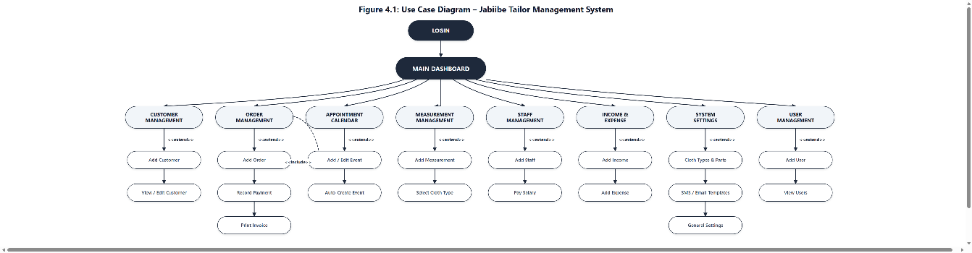
Figure 4.1: Use Case Diagram
Use Case | Description
Login & Authenticate | Verifies a user’s username and password against the users table before granting access to the system (see index.php / signin_post.php). The system supports more than one user account, each with identical full access — there is no separate, restricted role.
Manage Users | Add and view user (login) accounts — full name, address, phone number, username and password — so that more than one member of staff can sign in to the system. A user cannot delete their own account, and the last remaining account cannot be deleted, so the system can never be left without a way to log in.
Manage Customers | Add, view, edit and delete customer records (full name, address, phone number, city, email, sex, comment). Deletion requires confirmation before it is executed.
Manage Measurements | Record body measurements for a customer, organised by cloth type and by measurement part (Waist, Chest, Hips, Sleeve Length, etc.), each illustrated with a reference photo. The active cloth types were simplified to one per sex — TOP for female customers and SUIT for male customers — each showing only the measurement parts needed in practice, after the original six-type list (Shirt, Trouser, Suit, Skirt, Gown, Blouse) was found to be more than the business actually used.
Manage Orders | Create a new order for a customer, record the amount and amount paid, assign the staff member who received the order, mark it completed, record payments and print an invoice/receipt.
Manage Appointment Calendar | View, add, edit and delete calendar events. An event is created automatically whenever a new order is placed, using the order’s received and collection dates.
Manage Staff & Payroll | Add and edit staff records, assign a staff designation (Tailor, Counter, Security, Manager) and process salary payments.
Manage Income & Expenses | Record income and expense transactions under configurable categories, used to compute the last-30-day income/expense figures shown on the dashboard.
Configure System | Maintain supporting data — cloth types, measurement parts, SMS/email templates and general settings such as shop name and currency.

Entity Relationship Diagram (ERD)
The system is backed by a relational MySQL database, designed following the entity-relationship modelling approach described by Connolly and Begg (2015). Figure 4.2 shows the core entities and how they relate to one another. Primary keys are marked PK and foreign keys are marked FK.
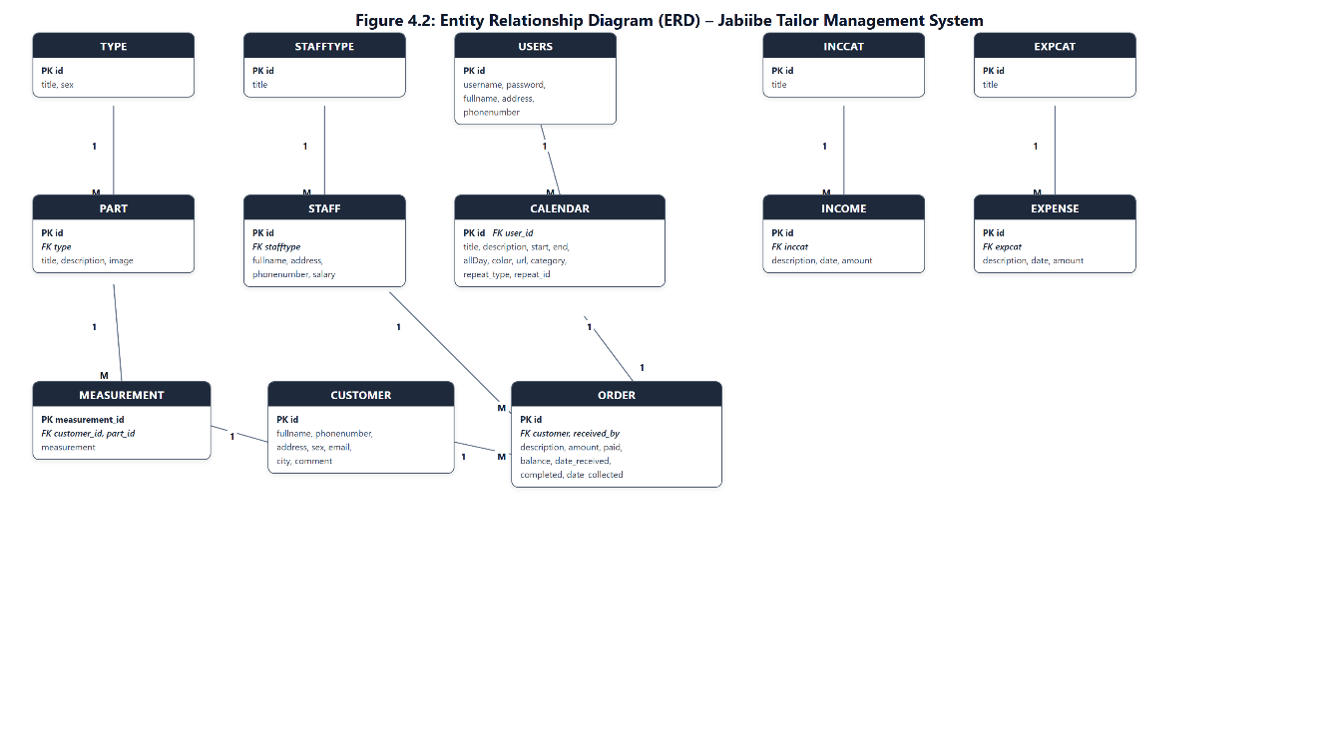
Figure 4.2: Entity Relationship Diagram (ERD)
The relationships shown in Figure 4.2 can be summarised as follows:
- A CUSTOMER can place many ORDERs, and can have many MEASUREMENT records (one-to-many).
- A TYPE (cloth type) has many PARTs (measurement points), and each PART is referenced by many MEASUREMENT records (one-to-many).
- A STAFFTYPE classifies many STAFF members, and a STAFF member can be assigned to (receive) many ORDERs (one-to-many).
- Each ORDER automatically generates one corresponding CALENDAR entry, which is also linked to the USERS account that created it. The USERS table itself was extended during development to store each account’s full name, address and phone number in addition to its username and password, so that more than one named user can be added and identified in the system (Section 4.1–4.3.7).
- Income and expense records are grouped under their own category tables — INCCAT → INCOME and EXPCAT → EXPENSE — which are independent of the customer/order data and support the financial reporting shown on the dashboard.
In addition to the entities shown in the diagram, the database includes a small number of supporting/utility tables that are not central to the core business relationships: general_setting (shop name, currency, SMS gateway), template (SMS/email message templates), documents (office document uploads) and sms / email (outgoing message logs).

System Architecture Diagram
Chapter Three introduced the system at the level of a three-tier client-server model — client, server and database. Figures 4.1 and 4.2 describe the system from a behavioural and a data point of view; Figure 4.3 now expands that same three-tier model into a more detailed structural view of the server tier, splitting it into an application layer and a data access layer and showing the technology used to implement each of the resulting four layers — presentation, application, data access and database.
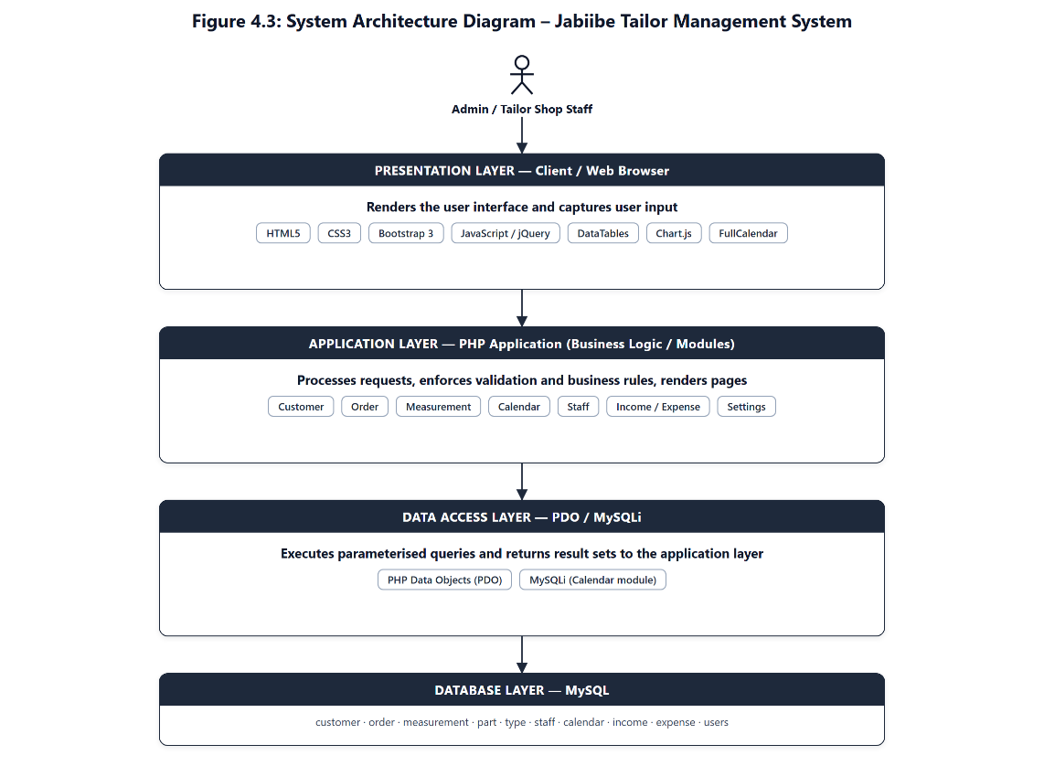
Figure 4.3: System Architecture Diagram
As Figure 4.3 shows, the user interacts only with the presentation layer in the browser (HTML5, CSS3, Bootstrap 3 and JavaScript/jQuery, together with the DataTables, Chart.js and FullCalendar libraries used for listings, the dashboard chart and the appointment calendar) — corresponding to the client tier of Chapter Three’s model. Every request from the browser is handled by the application layer — the PHP scripts that implement each functional module (Customer, Order, Measurement, Calendar, Staff, Users, Income/Expense, Settings) and enforce the validation and business rules described in Section 4.2. The application layer never talks to MySQL directly; it goes through a data access layer (PHP Data Objects for the main application, MySQLi for the self-contained Calendar module), which in turn reads from and writes to the database layer. Together, the application and data access layers make up the server tier of the three-tier model, and the database layer corresponds to the database tier. Separating the server tier into these two layers keeps the business logic and the raw SQL from being mixed together in the same block of code, which is what made it possible to fix defects such as the calendar’s invalid MySQLi constant (Section 5.1) without touching the presentation layer at all.

System Module Interconnection Diagram
Where Figure 4.3 shows the system as horizontal layers, Figure 4.4 shows it as functional modules, and how those modules interact with one another at run time — i.e. how the system works as a single connected whole rather than as a set of isolated screens.
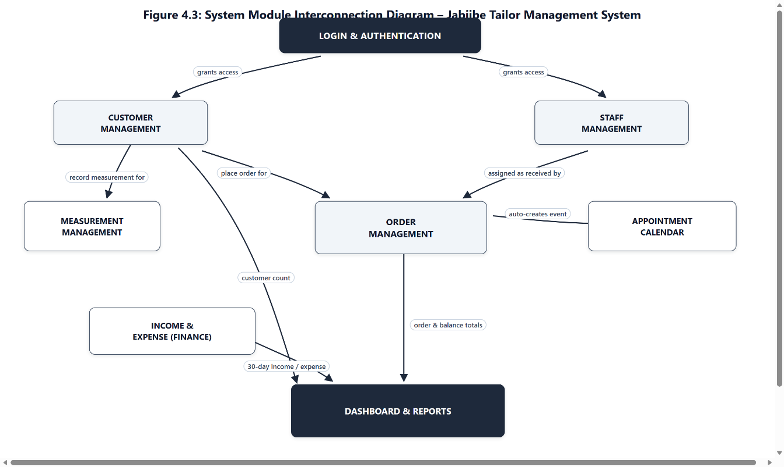
Figure 4.4: Module Interconnection Diagram
As Figure 4.4 shows, every module sits behind the Login & Authentication gate, which is why every page in the system checks the current session before rendering. From there, Customer Management acts as the central hub of the system: a customer record must exist before a measurement can be recorded against it or an order can be placed for it, so both the Measurement and Order modules are reached directly from the customer list (the “Add Meas” and “New Order” actions). Staff Management feeds into Order Management in the same way, since every order records which staff member received it. Placing an order, in turn, automatically creates a matching entry in the Appointment Calendar, so the calendar always mirrors the current order book without needing to be maintained separately. Finally, three modules — Customer Management, Order Management and Income & Expense — all feed summary totals into the Dashboard, which is why the dashboard cards and chart update automatically as customers, orders and financial transactions are added, without any extra step required from the admin.

Development Process

Development Methodology
The system was built using an iterative and incremental development approach, of the kind described by Sommerville (2016) and Pressman and Maxim (2020) as well suited to projects where requirements are refined through direct contact with a working system. Rather than designing every module up front and implementing it in a single pass, each module of the system (Customers, Orders, Measurements, Calendar, Staff, Income/Expense, Dashboard) was built, tested against real data in the local development environment, and then refined based on issues observed during actual use — for example, correcting the dashboard’s income calculation once it was noticed that the chart was not reflecting real figures, and reworking the navigation menu after observing that it was inconsistent between the main application and the Calendar module. This mirrors an Agile-style workflow: small, testable increments followed by review and refinement, rather than a rigid single-pass Waterfall process. Figure 4.5 summarises the process followed for each module, from initial requirements through to a fixed, working feature.
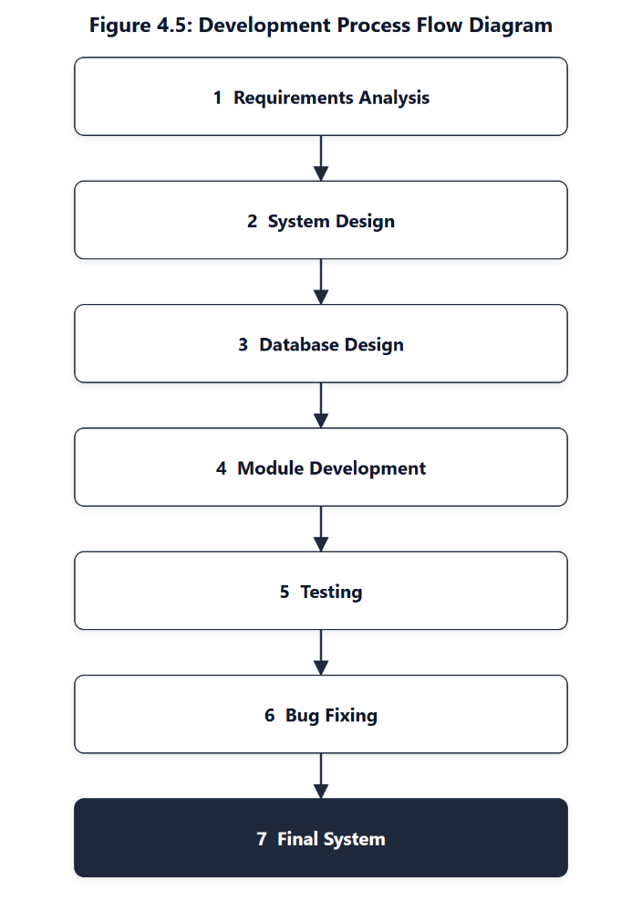
Figure 4.5: Development Process Flow
In practice, the last three steps — Module Development, Testing and Bug Fixing — were repeated for each module rather than executed once for the whole system: a module was built, tested immediately against the running application, and any defect found was fixed and re-tested before development moved on to the next module. Chapter Five reports the outcome of that testing in full.

System Architecture and Technology Stack
The Jabiibe Tailor Management System is a server-rendered web application built on the following stack. The front-end markup and scripting follow standard practice for HTML, CSS and JavaScript development (Duckett, 2014, 2022), while the server-side language and database layer follow established PHP/MySQL web-development practice (Nixon, 2021; Welling & Thomson, 2017).
Layer | Technology
Server-side language | PHP
Database | MySQL, accessed through PHP Data Objects (PDO)
Web server / local environment | Apache (XAMPP)
Front-end markup & styling | HTML5, CSS3 (custom teal design system), Bootstrap 3 grid
Client-side scripting | JavaScript, jQuery, jQuery UI
Data tables & listings | DataTables plug-in (search, sort, pagination)
Charts | Chart.js (Income / Expenses / Profit dashboard chart)
Appointment calendar | FullCalendar (AJAX-driven, backed by a dedicated calendar module with its own PHP/MySQLi data layer)

Database Design and Implementation
The database was implemented in MySQL using the entities described in Section 4.1.2. Each core module of the application maps to one or more tables: customer and measurement support the Customer module; order and calendar support the Order module; staff and stafftype support the Staff module; and income/inccat and expense/expcat support the financial reporting shown on the dashboard. Referential relationships (customer → order, type → part → measurement, staff → order) are enforced at the application layer through PDO queries rather than declared foreign-key constraints, which is consistent with the lightweight MyISAM/InnoDB mix used across the schema.

Implementation Highlights
The implementation was carried out module by module. The following points highlight the key implementation decisions and refinements made in each area:
- Authentication: A PHP session created at signin_post.php protects every page; any page that does not detect a valid session redirects the user back to the login screen. A Users module was added so that more than one named account can sign in, each with the same full access; the system prevents a user from deleting their own account or the last remaining account, so it can never be locked out of itself.
- Customer & Order forms: Both the Add Customer and Add Order forms were hardened with client-side required validation and matching server-side checks in PHP, so that a record can no longer be saved with empty fields — a problem that previously allowed blank dates to be stored as 0000-00-00 and blank text fields to be stored as empty strings.
- Measurement capture: The Add Measurement screen dynamically loads the correct set of body parts for the customer’s cloth type and sex directly from the type and part tables, and was redesigned from a plain HTML table into a responsive card/grid layout with reference photos for each measurement point.
- Dashboard analytics: The dashboard aggregates total customers, total orders, and income/expenses for the last 30 days, and renders a 30-day Income/Expense/Profit trend chart. A date-format mismatch between the chart’s income query (which compared m/d/Y strings against MySQL DATE columns stored as Y-m-d) was identified and corrected so that the chart reflects real transaction data.
- Appointment calendar: The Calendar module is a self-contained AJAX-driven component (its own connection.php, calendar.php class and cal_*.php endpoints) that automatically receives a new event whenever an order is created, and was updated to run cleanly under the deprecation rules of modern PHP (explicit class properties, corrected MySQLi constants) and to share the same visual theme as the rest of the application.
- Consistent navigation and theme: A single teal-based visual theme (colour tokens, sidebar, header) was applied consistently across the main application and the Calendar module, and the sidebar navigation was reorganised so that Orders and Customers open directly on their list/view screens, with a dedicated “Add” button available from each list.

Testing
Testing was carried out continuously during development rather than as a single phase at the end. Each new or modified feature was exercised directly in the browser against the live XAMPP/MySQL environment: forms were submitted with both valid and empty data to confirm that validation correctly blocked incomplete records; the dashboard chart was checked against known income/expense entries; and the Calendar module was reloaded after each fix to confirm that it no longer raised PHP errors. This approach allowed defects — such as the invalid MYSQL_ASSOC constant that was crashing the calendar, or the date-format bug in the income chart — to be caught and corrected close to the point where they were introduced.

User Interface Design
The user interface follows a single consistent visual language across the whole system: a fixed left-hand navigation sidebar, a teal (#0d9488) colour theme, card-based panels with rounded corners and soft shadows, and Bootstrap-based responsive forms and data tables. Table 4.1 summarises the main screens; each is illustrated with an actual screenshot of the running system below.
Table 4.1: Main System Screens and Key Interface Elements
Screen | Purpose | Key Interface Elements
Sign In | Authenticate the admin before granting access to the system. | Split-panel layout with a welcome/brand panel and a username/password form with a show/hide password toggle.
Dashboard | Give the admin an at-a-glance summary of the business. | Four stat cards (Total Customers, Total Orders, Last 30-Day Income, Last 30-Day Expenses) and a 30-day Income/Expense/Profit trend chart.
Customers (list) | Browse, search and act on customer records. | Searchable/sortable data table with per-row actions (New Order, Add/Edit Measurement, SMS, Email, Delete) and an “Add Customer” button.
Add Customer | Capture a new customer’s details. | Validated form (Full Name, Address, Phone, City, Email, Sex, Comment) with a link back to the customer list.
Orders (list) | Browse and act on orders. | Data table showing customer, description, dates and balance, with Add Payment, Receipt, Update and Delete actions.
Add Order | Create a new order for a customer. | Validated form linking a customer, a staff member (Received By), dates and amounts; automatically creates a matching calendar event.
Add Measurement | Capture body measurements for a customer’s garment. | Customer banner followed by a single card for the customer’s cloth type (TOP for female, SUIT for male), showing a responsive grid of the relevant measurement points with a reference photo and numeric input field.
Calendar | Visualise orders and appointments over time. | Month-view AJAX calendar (FullCalendar) with add/edit/delete/search event support.
Users (list) | Browse existing user accounts and add new ones. | Data table of Full Name, Address, Phone and Username with a Delete action (disabled for the current account and for the last remaining account) and an “Add User” button.
Add User | Create a new login account. | Validated form (Full Name, Address, Phone, Username, Password) matching the Add Customer layout.
Income / Expenses | Record and review income and expense transactions. | Category-based entry form plus a searchable/sortable list with Add and Delete actions, feeding the dashboard’s 30-day totals.

Sign In Screen
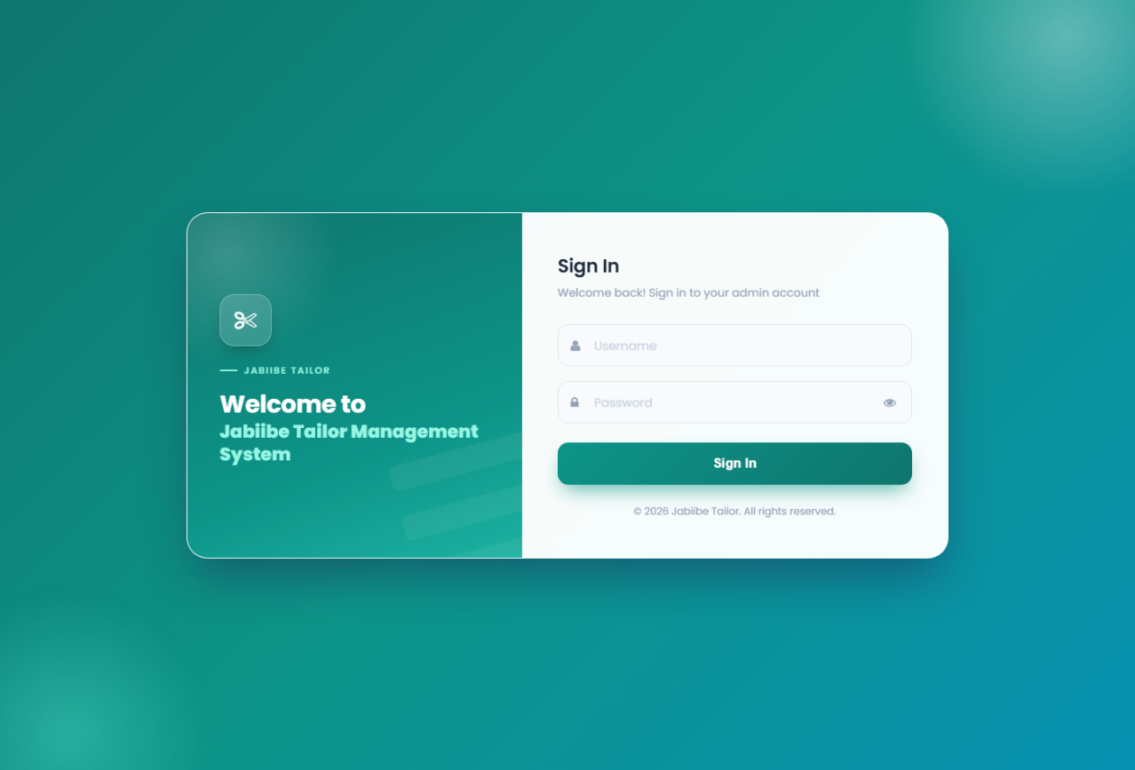
Figure 4.6: Sign In Screen

Dashboard
The dashboard follows the role that Laudon and Laudon (2020) and O’Brien and Marakas (2018) describe for a management information system: presenting summarised, timely data so that day-to-day decisions can be made without querying the underlying records directly.
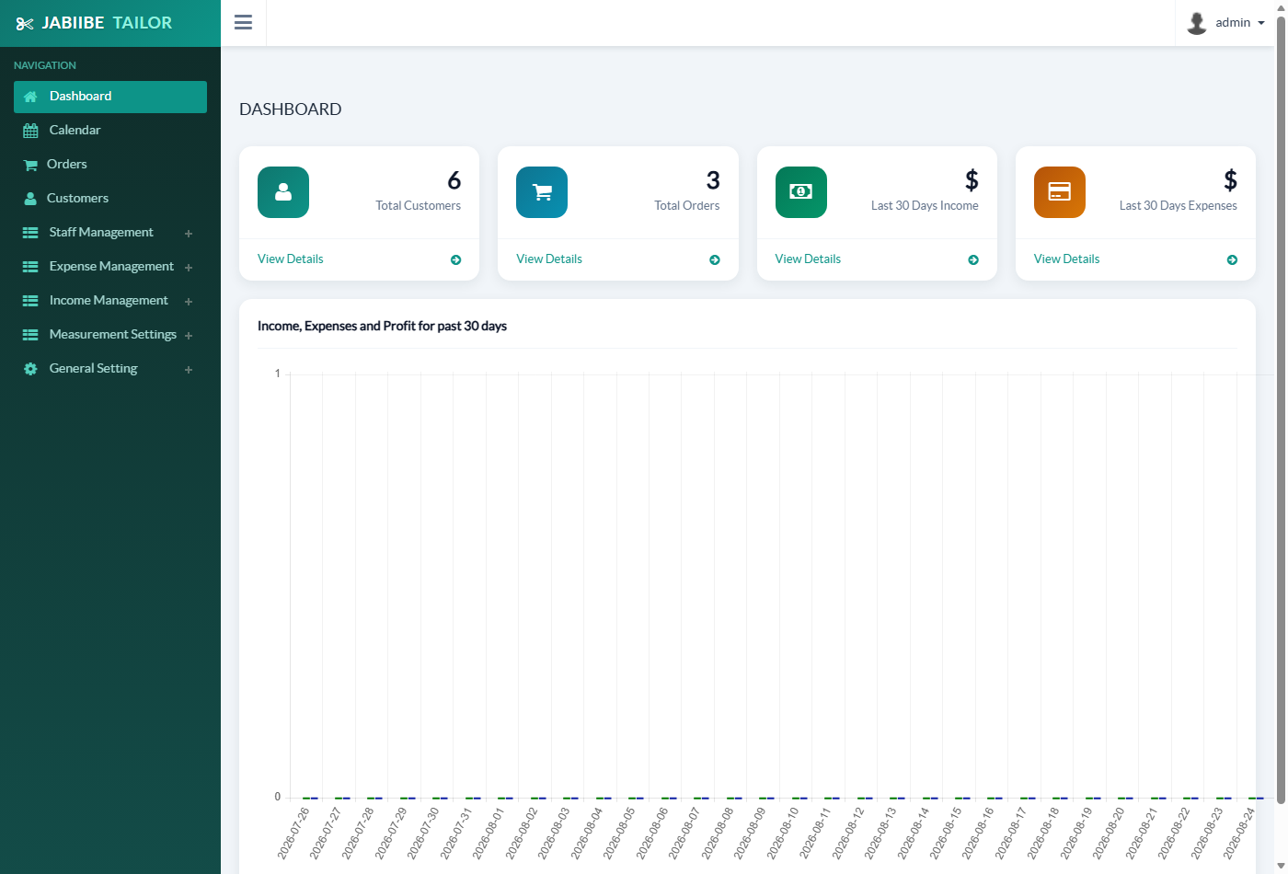
Figure 4.7: Dashboard Summary and Financial Chart

Customer Management
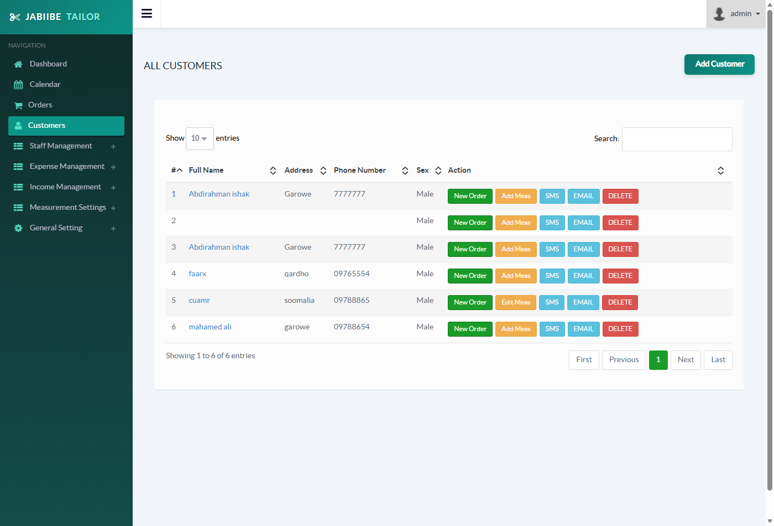
Figure 4.8: Customer List Screen
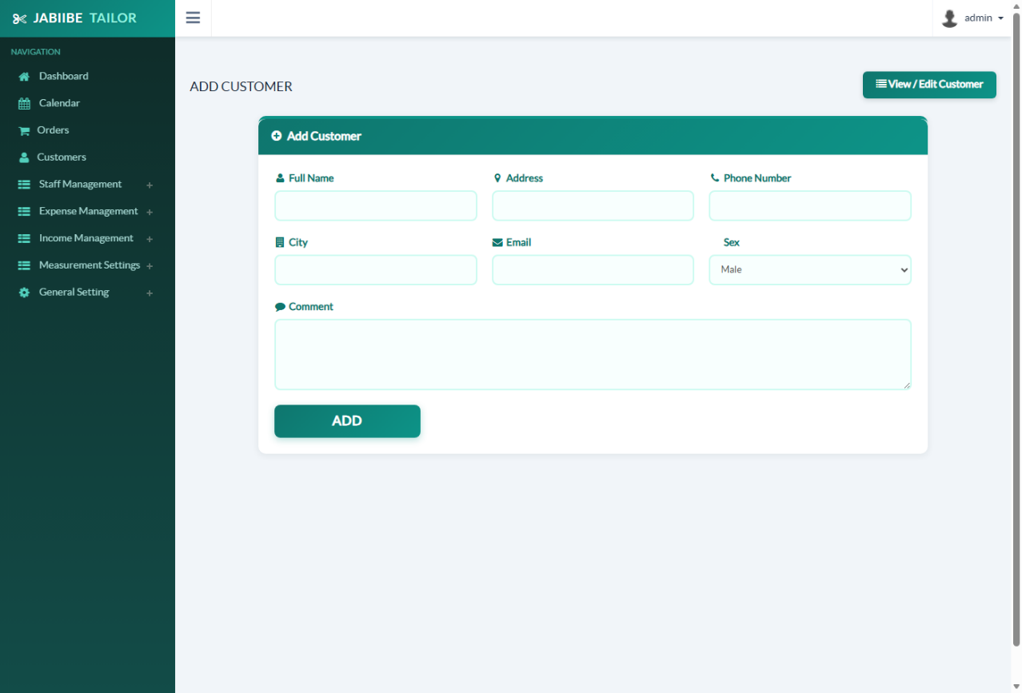
Figure 4.9: Add Customer Screen

Order Management
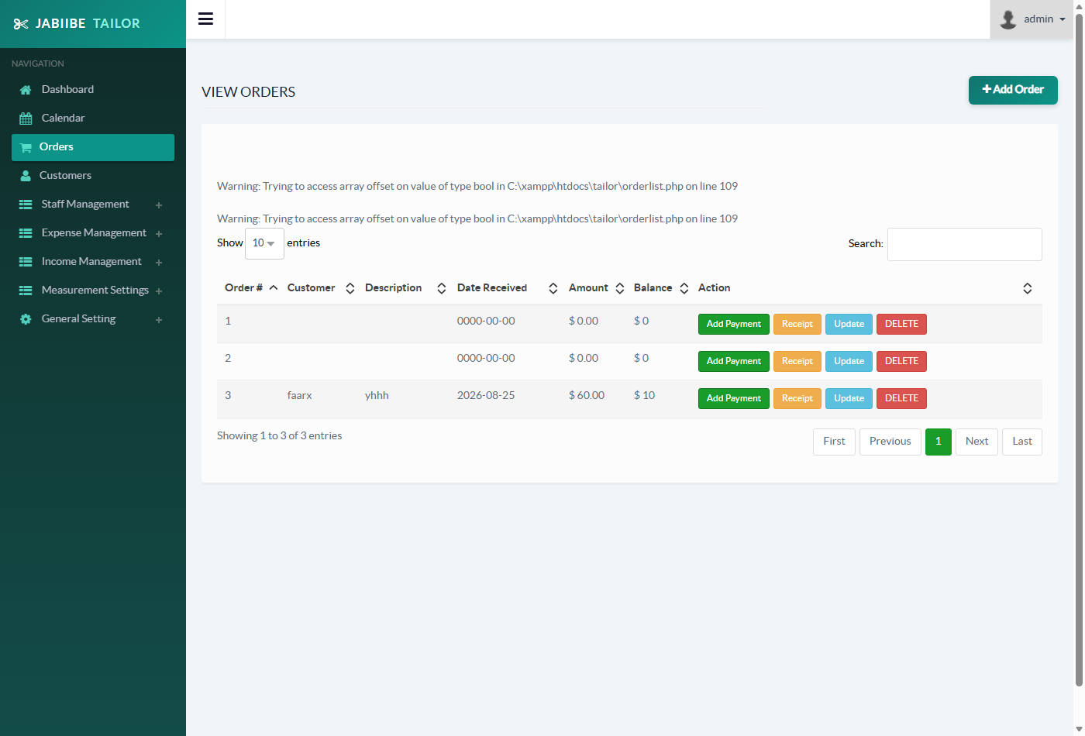
Figure 4.10: Order List Screen
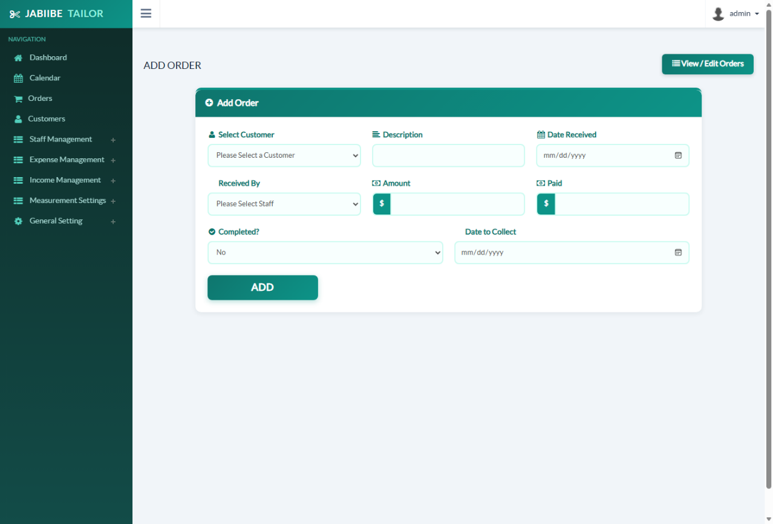
Figure 4.11: Add Order Screen

Measurement Management
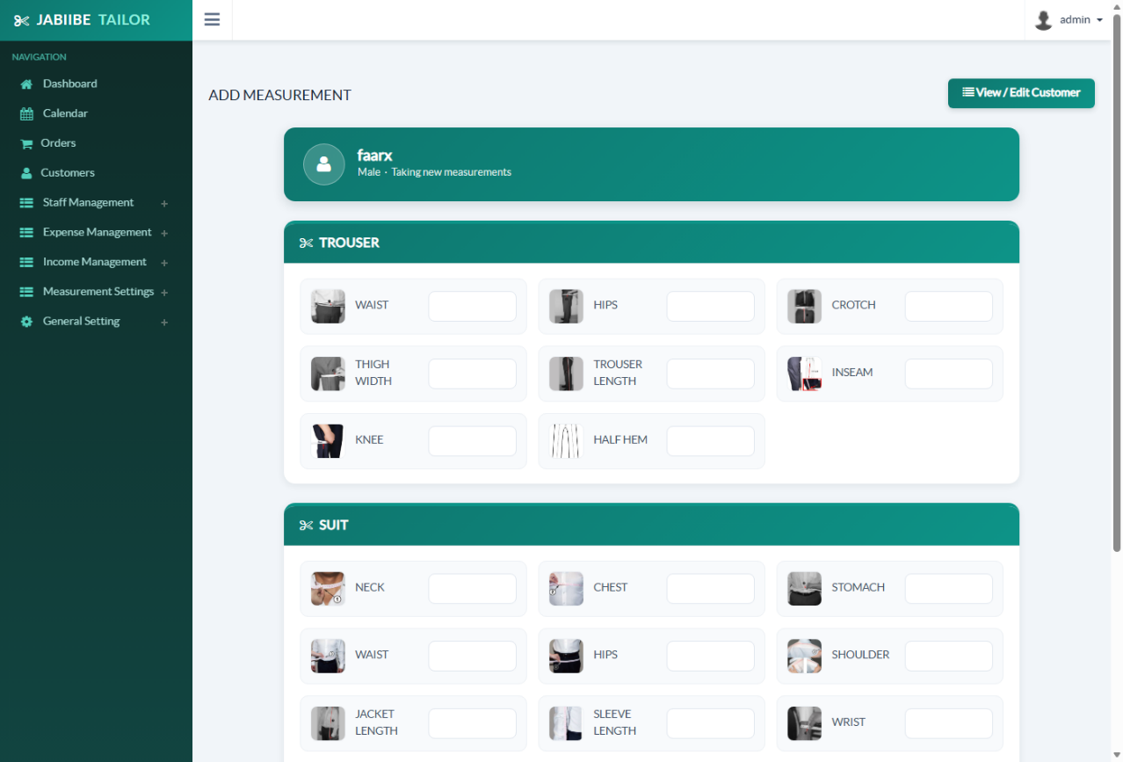
Figure 4.12: Add Measurement Screen

Appointment Calendar
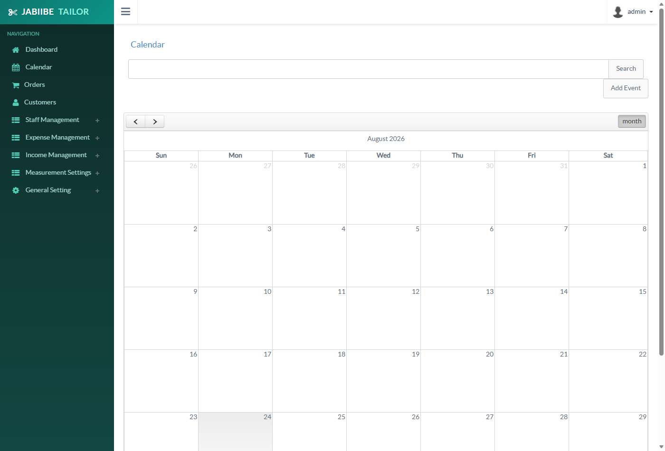
Figure 4.13: Appointment Calendar

User Management
The Users module was added after the initial release so that more than one member of staff could sign in to the system under their own name rather than sharing a single account. Figure 4.14 shows the list of existing accounts and Figure 4.15 the form used to add a new one; both follow the same visual layout as the Customer screens in Section 4.3.3.
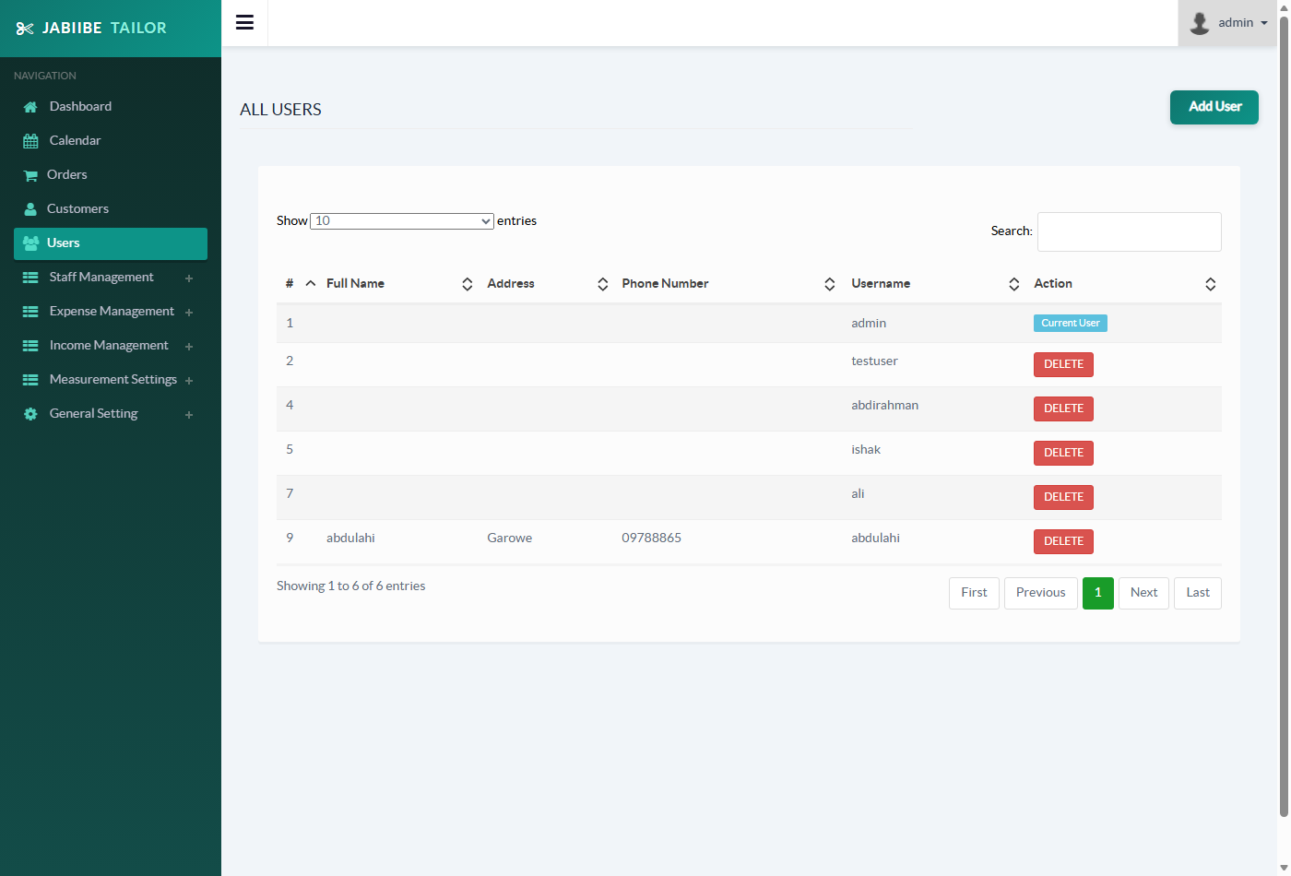
Figure 4.14: Users List Screen
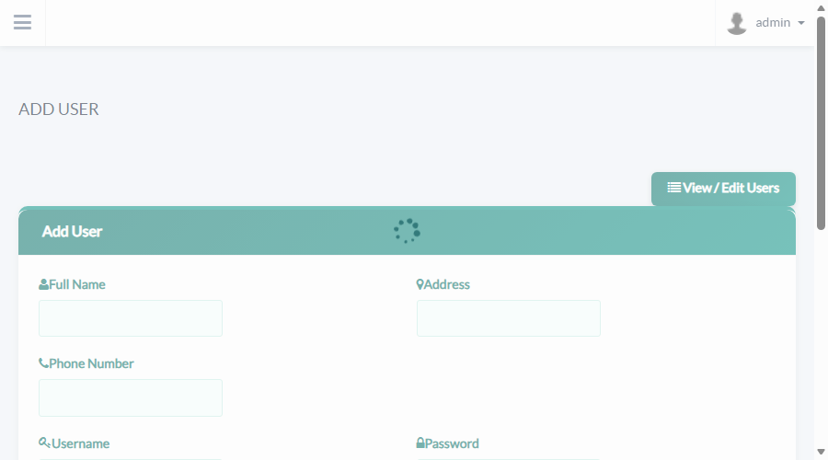
Figure 4.15: Add User Screen

Income and Expense Management
The Income and Expense screens capture the transactions summarised on the Dashboard (Section 4.3.2). Figure 4.16 shows the Add Income form and Figure 4.17 the Expenses list; the Add Expense form and Income list share the same respective layouts.
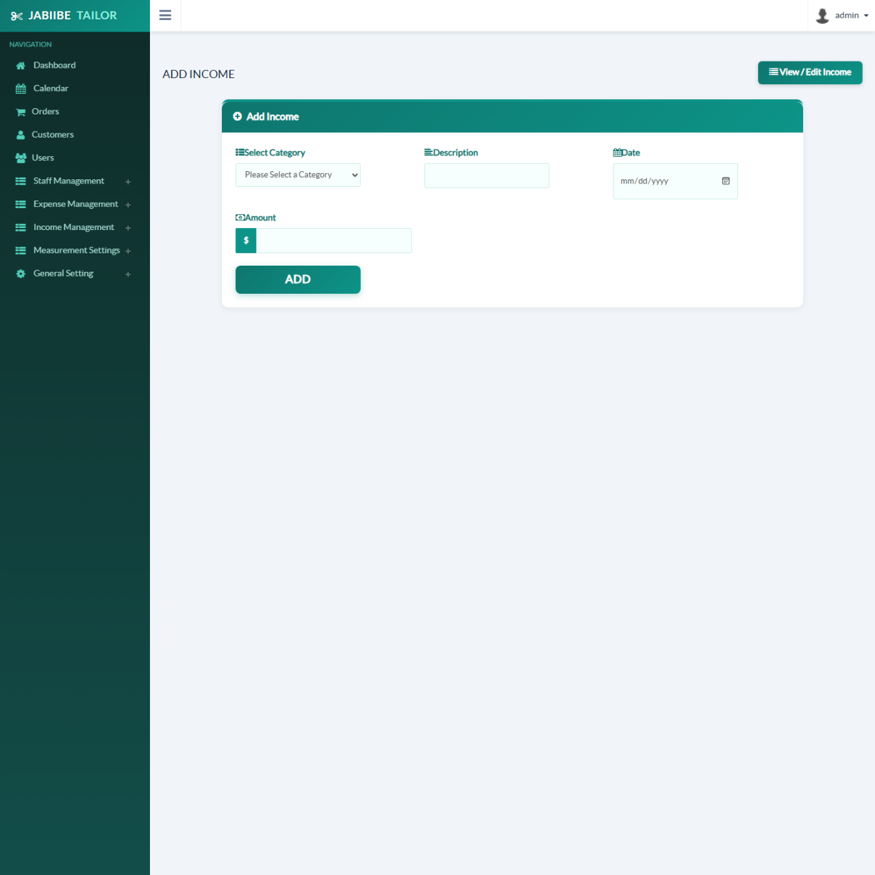
Figure 4.16: Add Income Screen
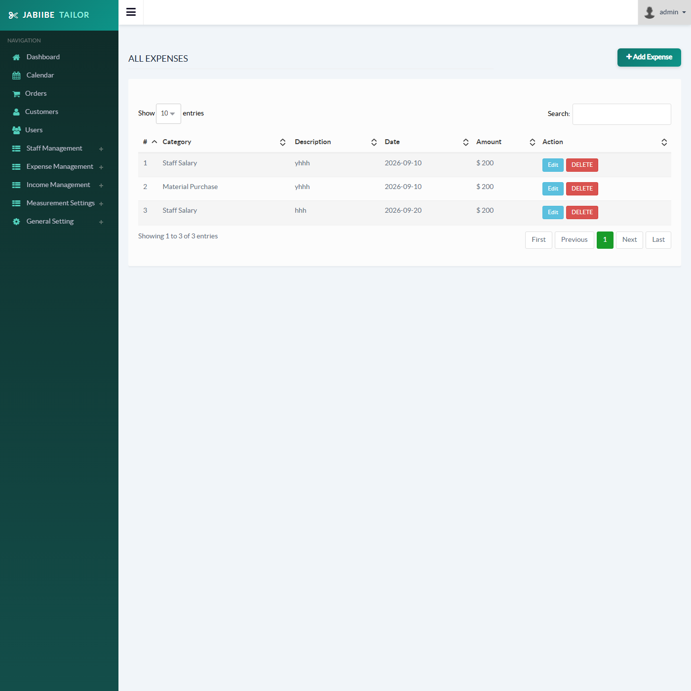
Figure 4.17: Expenses List Screen

CHAPTER FIVE

RESULTS AND DISCUSSION

Introduction
Chapter Four described how the Jabiibe Tailor Management System was designed and built. This chapter reports the results obtained from testing that system, analyses its performance, and interprets what those results mean for the project as a whole. Testing was carried out continuously against the live application running on a local Apache/MySQL (XAMPP) environment rather than as a single event at the end of development, so the results presented here include both the defects that were found during that process and confirmation that each one was subsequently resolved. The specific objectives against which these results are assessed are: (i) to enable tailors to manage customer records, garment orders and tailoring services efficiently; (ii) to improve data security and maintain accurate records through a computerised database system; and (iii) to improve communication and customer satisfaction by providing timely information about orders, costs and service updates, as stated in Chapter One.

Testing Results
Testing followed a manual, black-box approach: each module was exercised directly through the browser using both valid data (positive test cases) and missing/invalid data (negative test cases), and the actual behaviour of the system was compared against the expected behaviour. Table 5.1 lists a representative sample of the functional test cases executed against the system, showing the result observed before correction alongside the result confirmed after correction; Table 5.2 summarises the complete defect log compiled over the course of testing, together with the severity and resolution status of each item.
Table 5.1: Sample Functional Test Cases
Module | Test Case | Expected Result | Actual Result (Before Correction) | Result After Correction | Status
Add Customer | Submit the form with all fields left empty | Form is rejected; no record is saved | A blank customer record was saved to the database | Submission is blocked client- and server-side; an error message is shown and no record is saved | Pass
Add Order | Submit the form with the date fields left empty | Form is rejected; no record is saved | Order was saved with dates stored as 0000-00-00 | Submission is blocked; the order is only saved once valid dates are supplied | Pass
Customer / Order List | Click DELETE on a row | A confirmation prompt appears before deletion | The record was deleted immediately, with no confirmation | A confirmation prompt now appears; deletion proceeds only if confirmed | Pass
Appointment Calendar | Open the Calendar module | Month view loads with existing events visible | PHP Fatal Error — Undefined constant “MYSQL_ASSOC” — the calendar failed to load | Month view loads correctly with existing events visible | Pass
Dashboard | View the 30-day Income/Expenses/Profit chart against known income records | The chart reflects the real income total for each day | The Income series always showed 0, regardless of actual data | The chart reflects the actual recorded income for each day | Pass
Add Order | Open Add Order while the staff table is empty | A clear message guides the admin to add a staff member first | The “Received By” dropdown simply appeared empty, with no explanation | A message is displayed with a direct link to the Add Staff screen | Pass
Appointment Calendar | Load the Calendar module under PHP 8.2 | The page renders cleanly with no interpreter warnings | “Deprecated: Creation of dynamic property” warnings were printed above the page content | The page renders with no interpreter warnings | Pass
Customer List | Resize the browser window / view the Action column on a narrow screen | Action buttons wrap cleanly with visible spacing | Buttons were touching, with no spacing between them | Buttons wrap with visible spacing at all tested widths | Pass
Table 5.2: Defect Log
ID | Module | Defect | Severity | Status
D01 | Appointment Calendar | Fatal error on load caused by the invalid MySQLi constant MYSQL_ASSOC | Critical | Fixed & re-verified
D02 | Dashboard | Income chart always computed as 0 due to a date-format mismatch (m/d/Y compared against Y-m-d columns) | High | Fixed & re-verified
D03 | Add Customer / Add Order | No required-field validation; forms could be submitted empty, producing blank or 0000-00-00 records | High | Fixed & re-verified
D04 | Customer / Order List | Destructive one-click delete with no confirmation prompt | Medium | Fixed & re-verified
D05 | Navigation / Sidebar | Sidebar links were inconsistent between the main application and the Calendar module, and mixed “Add” and “View” destinations confusingly | Medium | Fixed & re-verified
D06 | Appointment Calendar | Visual theme (colours, logo, sidebar) did not match the rest of the application | Low | Fixed & re-verified
D07 | Appointment Calendar | PHP 8.2 “deprecated dynamic property” warnings printed above the page | Low | Fixed & re-verified
D08 | Customer / Order List | Action-column buttons cramped together with no spacing, wrapping poorly | Low | Fixed & re-verified
D09 | Add Measurement | Measurement points displayed as a single dense column with heavy bold text | Low | Fixed & re-verified
D10 | Add Order | “Received By” dropdown gave no explanation when the staff list was empty | Low | Fixed & re-verified
D11 | Footer (all pages) | Unrelated third-party branding/credit text displayed in the page footer | Low | Fixed & re-verified
D12 | Order List | PHP warning (“Trying to access array offset on value of type bool”) when an order referenced a customer that had since been deleted | Low | Fixed & re-verified
Of the twelve defects logged, one (D01) was classified as critical because it prevented an entire module from loading at all; two (D02, D03) were classified as high severity because they silently produced incorrect or invalid data without any visible error; the remainder were medium- or low-severity usability, consistency and edge-case issues. All twelve were corrected and then re-verified by reloading the affected page or resubmitting the affected form, as recorded in the “Result After Correction” column of Table 5.1.

System Performance Analysis
Formal load-testing tools were not used, since the system is designed for a single small tailoring business with one administrative user rather than a high-concurrency public service. Instead, performance was measured by timing real HTTP requests against the running application: each of the seven main pages was requested five times through an authenticated session, and the average response time was recorded. These measurements were taken against the local Apache/MySQL (XAMPP) development server described in Section 4.2.2, with the database in its current working state (6 customer records, 3 orders, 24 measurement entries, 3 staff records and 3 calendar events); they characterise development-environment behaviour only and should not be read as a prediction of production performance, which would depend on production server hardware, network conditions and a larger, live dataset.
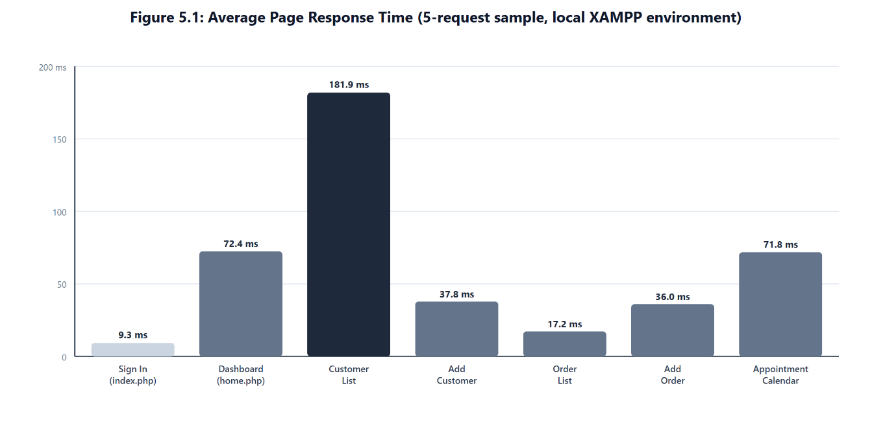
Figure 5.1: Average Page Response Time
Table 5.3: Average Page Response Time
Page | Average Response Time
Sign In (index.php) | 9.3 ms
Dashboard (home.php) | 72.4 ms
Customer List (customerview.php) | 181.9 ms
Add Customer (customeradd.php) | 37.8 ms
Order List (orderlist.php) | 17.2 ms
Add Order (orderadd.php) | 36.0 ms
Appointment Calendar (calendar/index.php) | 71.8 ms
As Figure 5.1 and Table 5.3 show, all seven pages demonstrated acceptable response times under the stated test conditions, each returning in well under a quarter of a second. The Customer List page stood out as the slowest of the sample at 181.9 ms — roughly 2.5× the Dashboard and Calendar pages, and 10× the Sign In page. This is attributable to an N+1 query pattern in customerview.php, which issues one extra database query per customer row rather than a single combined query; the same pattern exists in orderlist.php, but has a smaller effect there because it currently has fewer rows to iterate over. A full technical explanation of this pattern is given in Appendix A, since it is an implementation-level detail rather than a core result.
At the system’s current data volume this pattern has no noticeable effect on usability, but it is the clearest scalability risk identified during testing, and the corresponding recommendation is carried forward to Section 5.5 and Chapter Six.

Interpretation of Findings
Taken together, the testing and performance results support three conclusions about the system as it stands at the end of this project, assessed against the objectives set out in Chapter One.
First, the system is now functionally reliable. Every defect identified during testing — from the calendar’s fatal error to the dashboard’s silently incorrect chart to the forms that accepted empty input — was traced to a specific, identifiable cause and corrected, and each fix was re-verified against the running system rather than assumed to work. This directly supports Objective (ii), to improve data security and maintain accurate records through a computerised database system: the defects that most threatened record accuracy (blank and 0000-00-00 records, an incorrect income chart) were the ones prioritised for correction, and none of the twelve logged defects reflected a flaw in the overall design described in Chapter Four — all were implementation-level issues of the kind that manual, continuous testing is well suited to catching.
Second, performance demonstrated acceptable response times under the stated test conditions. Every page tested responded in under 200 milliseconds against the local development server, supporting Objective (i), to enable tailors to manage customer records, garment orders and tailoring services efficiently, and Objective (iii), to improve communication and customer satisfaction by providing timely information about orders, costs and service updates — an admin retrieving an order, a balance or a customer’s record does so with no perceptible delay under these test conditions. The one performance-related finding of note — the N+1 query pattern behind the Customer List page — is not a defect in the sense of incorrect behaviour; it is a scalability consideration that only becomes relevant if the business, and therefore its customer table, grows substantially, and it has not been tested under production load or with a production-scale dataset.
Third, the exercise highlighted where the system should be hardened before that growth happens. Based on the defect log and the performance analysis, three concrete recommendations follow directly from the results in this chapter:
- Replace the per-row measurement and customer lookups in customerview.php and orderlist.php with a single joined query, to keep list-page performance flat as the number of customers and orders increases.
- Extend the required-field validation already added to the Customer, Order and Staff forms to the remaining data-entry forms in the system (Income, Expense, Cloth Type, Measurement Part), since the same class of “empty submission” defect could exist there too.
- Introduce a small suite of automated regression tests for the defects listed in Table 5.2, so that future changes to the codebase cannot silently reintroduce a fault that has already been found and fixed once.
None of these recommendations point to a redesign of the system; they are refinements to an implementation that, by the evidence gathered in this chapter, already meets the functional and performance objectives set out for it. These recommendations are developed further in Chapter Six.

Limitations of the Study
The results presented in this chapter should be read with the following limitations in mind:
- Local testing environment. All functional and performance testing was carried out on a local XAMPP (Apache/MySQL/PHP) installation on a single development machine, not on a production server. Network conditions, concurrent-user load and server hardware in a live deployment may produce different results from those reported in Section 5.3.
- Small dataset. Testing was performed against a working dataset of 6 customers, 3 orders, 24 measurement entries and 3 staff records. This was sufficient to exercise every module and to expose the N+1 query pattern described in Section 5.3, but it is too small to draw firm conclusions about performance at production scale, where a tailoring business might accumulate hundreds or thousands of customer and order records.
- No formal load or stress testing. Performance was assessed using sequential, single-user HTTP requests (Section 5.3). No tool was used to simulate multiple concurrent users, so the system’s behaviour under concurrent load is not established by this study.
- No formal security testing. Testing focused on functional correctness and was not a security audit. As noted in Chapter Six, every form in the system, including the Customer, Order and Staff forms that were hardened with input validation during this project, still builds SQL statements by directly concatenating user input; this is a security weakness that this study identifies but does not fully remediate.
- Manual, black-box testing only. All testing in this chapter was performed manually by exercising the running application; no automated unit or regression test suite exists for the codebase, which is carried forward as a recommendation in Section 5.4.

CHAPTER SIX

SUMMARY, CONCLUSION AND RECOMMENDATIONS
Chapters Four and Five described how the Jabiibe Tailor Management System was designed, built and tested. This chapter closes the report by summarising what was found against the specific objectives stated in Chapter One, drawing a conclusion from that evidence, and setting out recommendations for taking the system further.

Summary of Findings
Chapter One set out four specific objectives for this project. Table 6.1 restates each objective exactly as given in Chapter One and summarises, against the evidence gathered in Chapters Four and Five, what the finished system was found to actually deliver.
Table 6.1: Specific Objectives and Project Outcomes
No. | Specific Objective (Chapter One) | Outcome
1 | To develop a user-friendly system that allows customers to register, submit measurements, and track garment progress online. | Partially achieved. The system provides a user-friendly, validated interface for capturing customer registration details and measurements (Sections 4.2.4, 4.3.3, 4.3.5), and garment progress is tracked through the order’s “completed” status (Section 4.1.2). However, the delivered system is operated entirely by the admin/staff on the customer’s behalf: there is no customer-facing login, and customers cannot themselves register, submit measurements or check progress online. This gap is carried forward as a recommendation in Section 6.3.
2 | To enable tailors to manage customer records, garment orders, and tailoring services efficiently. | Achieved. Customers, orders and measurements can be added, viewed, updated and (for customers and orders) deleted from a single consistent interface, with an appointment calendar generated automatically from order data (Sections 4.1.4, 4.3). Table 5.3 recorded response times of under 200 ms for every core page on the development server.
3 | To improve data security and maintain accurate records through a computerised database system. | Partially achieved. Record accuracy was directly improved: required-field validation now prevents the blank and 0000-00-00 records that testing found the original forms would accept (Table 5.1, D03). Data security, however, is only partially addressed — as discussed in Section 6.2, the validation added during this project prevents blank and malformed input but does not change how the resulting query is executed: every form in the system, including the ones just described, still builds SQL statements by concatenating user input directly, which is a security weakness that this study identifies but does not fully remediate.
4 | To improve communication and customer satisfaction by providing timely information about orders, costs, and service updates. | Partially achieved. Order costs, balances and status are available to the admin instantly (Table 5.3), and SMS/Email screens exist for sending customers updates. The SMS gateway is currently configured with placeholder, non-functional credentials (Section 6.3), so outbound SMS notification is not yet operational; email sending was not part of the defects tested in Chapter Five.
In addition to the objective-by-objective outcome above, Chapter Five reported twelve defects found during testing (Table 5.2), ranging from one critical fault that stopped the Appointment Calendar from loading at all, to low-severity usability issues such as cramped action buttons. All twelve were traced to a specific cause, corrected, and re-verified against the running system (Table 5.1). The performance analysis in the same chapter measured every page at under 200 milliseconds on the local development server, with one scalability risk identified: the Customer List page issues one extra database query per customer row, a pattern that is fast today but would slow down as the customer base grows (Section 5.3).

Conclusion
Based on the evidence gathered in Chapters Four and Five, four conclusions can be drawn about the project.
The system substantially meets the objectives set for it, with one objective only partially delivered. Objectives 2 was fully achieved and confirmed through direct testing against the live application, not merely assumed to work from the design. Objectives 1, 3 and 4 were achieved for their admin-facing core but not in full: the system has no customer self-service portal (Objective 1), a class of forms outside the Customer/Order/Staff modules still carries a data-security weakness described below (Objective 3), and outbound SMS notification is not yet functional pending real gateway credentials (Objective 4). Where testing found a gap between intended and actual behaviour that was within this project’s scope to fix — most importantly, forms that could be submitted empty and a dashboard chart that did not reflect real data — that gap was closed and re-verified before the project was considered complete.
Data security is a present weakness, not only a future risk. Section 6.3 recommends moving the system’s remaining raw, string-concatenated SQL statements to parameterised PDO queries. This is stated here as a current finding rather than a purely forward-looking suggestion: inspection of the codebase found that 34 of the system’s PHP files — including the Customer, Order, Staff, Income, Expense and User forms that were hardened with required-field validation during this project (Section 4.2.4) — still build INSERT/UPDATE statements by concatenating $_POST values directly into the SQL string. The validation work done during this project addressed what data reaches the database (rejecting empty or malformed submissions); it did not change how that data is assembled into a SQL statement, so the injection exposure remains even on the forms that were otherwise improved. This is an existing SQL-injection exposure across the system as delivered, and is treated as such in the recommendations below rather than deferred as a hypothetical enhancement.
The system currently has a single, undifferentiated Admin role. Every account in the users table (Section 4.1.2) has identical, full access to every module, including financial data and system settings; there is no lower-privileged “staff” or “counter” account type. This matches the project’s original scope of a single-admin tool, but is noted explicitly here because it is a design constraint of the current system, not an oversight to be inferred.
An iterative, test-as-you-go approach was well suited to a project of this size. Building and correcting one module at a time, against a live copy of the application, surfaced defects such as the Calendar module’s invalid MySQLi constant and the income chart’s date-format mismatch quickly and close to their source, rather than allowing them to accumulate until a separate testing phase, consistent with the iterative practice recommended by Sommerville (2016) and Pressman and Maxim (2020). This is reflected directly in the development process described in Section 4.2 and Figure 4.5. The technology choices — PHP, MySQL, server-rendered pages — match the scale of a single small tailoring business; the one performance-related weakness identified, the N+1 query pattern on the Customer List page, has no practical effect at the system’s current data volume and was assessed only under the local, single-user test conditions described in Section 5.5.

Recommendations for Future Work
The following recommendations follow directly from the findings in Chapters Five and Six, and are grouped by priority. The security item is listed first because, as noted in Section 6.2, it addresses a weakness that already exists in the delivered system rather than a purely future concern.

Immediate priority – current security weakness
- Move all remaining raw, string-concatenated SQL statements to parameterised PDO queries. As reported in Section 6.2, 34 PHP files across the system — including the Customer, Order, Staff, Income, Expense and User forms that already received required-field validation (Section 4.2.4) — still build INSERT/UPDATE statements by concatenating $_POST values directly into the query string, which is precisely the pattern that database-security practice warns against (Connolly & Begg, 2015; Laudon & Laudon, 2020). This should be corrected throughout, since input validation alone does not close the SQL-injection risk, before the system is used with untrusted or multi-user input.

Short-term (direct follow-on from testing)
- Replace the per-row measurement and customer lookups in customerview.php and orderlist.php with a single joined query, removing the N+1 pattern identified in Section 5.3 before the customer base grows large enough for it to matter.
- Extend the required-field validation already applied to the Customer, Order, Staff, Income and Expense forms (Section 4.2.4) to the remaining data-entry forms — Cloth Type and Measurement Part — which currently have no equivalent checks.

Medium-term
- Introduce a small suite of automated regression tests covering the twelve defects logged in Table 5.2, so that future changes cannot silently reintroduce a fault that has already been found and fixed once.
- Replace the placeholder SMS-gateway configuration in general_setting with a real, credentialed SMS provider, so that Objective 4 (timely order and cost updates to customers) is fully realised rather than only partially, as noted in Section 6.1.
- Introduce role-based access (e.g. a restricted “Counter Staff” login alongside the full Admin account), since the system currently has only the single, undifferentiated Admin role described in Section 6.2.

Longer-term
- Package the application for a live deployment: HTTPS, a non-default database user with least-privilege access, and routine database backups, none of which are required for the local XAMPP development environment used to build and test the system.
- Revisit the Appointment Calendar module, which currently duplicates the visual theme and session-handling logic of the main application rather than sharing it, to reduce the maintenance overhead of keeping two near-identical front ends in sync.
- Add a customer-facing self-service view (registration, measurement submission and order-progress tracking by phone number or account), to fully realise Objective 1, which the current admin-operated system only partially delivers.
None of these recommendations imply that the current system is unfit for use; each is a refinement to an application that, on the evidence gathered in this report, already performs its core, admin-facing job correctly and with acceptable response times under the tested conditions for a single tailoring business, while the security and customer-self-service items above identify specific, named gaps against the original objectives rather than general aspirations.

REFERENCES
Connolly, T., & Begg, C. (2015). Database systems: A practical approach to design, implementation, and management (6th ed.). Pearson.
Dey, S., Joshi, Y., & Sharma, A. (2019). Digital transformation of fashion industry: A case of online business models. Journal of Advances in Management Research, 16(3), [page range needed].
Duckett, J. (2014). JavaScript and jQuery: Interactive front-end web development. Wiley.
Duckett, J. (2022). HTML and CSS: Design and build websites. Wiley.
Kendall, K. E., & Kendall, J. E. (2019). Systems analysis and design. Pearson.
Laudon, K. C., & Laudon, J. P. (2020). Management information systems: Managing the digital firm. Pearson.
Nixon, R. (2021). Learning PHP, MySQL & JavaScript (6th ed.). O’Reilly Media.
O’Brien, J. A., & Marakas, G. M. (2018). Introduction to information systems. McGraw-Hill Education.
Pressman, R. S., & Maxim, B. R. (2020). Software engineering: A practitioner’s approach (9th ed.). McGraw-Hill Education.
Sharma, A., Jha, S., & Kumar, S. (2020). Digital transformation in fashion retail: A case study approach. International Journal of Technology Management & Sustainable Development, [volume(issue), page range needed].
Sommerville, I. (2016). Software engineering (10th ed.). Pearson.
Welling, L., & Thomson, L. (2017). PHP and MySQL web development (5th ed.). Addison-Wesley Professional.

APPENDIX A
SYSTEM SCREENSHOTS
Figure A1: Sign In Screen

APPENDIX A: SYSTEM SCREENSHOTS (CONTINUED)
Figure A2: Dashboard Summary and Financial Chart

APPENDIX B: SYSTEM ARCHITECTURE DIAGRAM
Figure B1: System Architecture Diagram

APPENDIX C: SYSTEM TESTING RESULTS AND PERFORMANCE FIGURE
Table C1: Sample Functional Test Cases
Figure C1: Average Page Response Time
Module | Test Case | Expected Result | Actual Result (Before Correction) | Result After Correction | Status
Add Customer | Submit the form with all fields left empty | Form is rejected; no record is saved | A blank customer record was saved to the database | Submission is blocked client- and server-side; an error message is shown and no record is saved | Pass
Add Order | Submit the form with the date fields left empty | Form is rejected; no record is saved | Order was saved with dates stored as 0000-00-00 | Submission is blocked; the order is only saved once valid dates are supplied | Pass
Customer / Order List | Click DELETE on a row | A confirmation prompt appears before deletion | The record was deleted immediately, with no confirmation | A confirmation prompt now appears; deletion proceeds only if confirmed | Pass
Appointment Calendar | Open the Calendar module | Month view loads with existing events visible | PHP Fatal Error — Undefined constant “MYSQL_ASSOC” — the calendar failed to load | Month view loads correctly with existing events visible | Pass
Dashboard | View the 30-day Income/Expenses/Profit chart against known income records | The chart reflects the real income total for each day | The Income series always showed 0, regardless of actual data | The chart reflects the actual recorded income for each day | Pass
Add Order | Open Add Order while the staff table is empty | A clear message guides the admin to add a staff member first | The “Received By” dropdown simply appeared empty, with no explanation | A message is displayed with a direct link to the Add Staff screen | Pass
Appointment Calendar | Load the Calendar module under PHP 8.2 | The page renders cleanly with no interpreter warnings | “Deprecated: Creation of dynamic property” warnings were printed above the page content | The page renders with no interpreter warnings | Pass
Customer List | Resize the browser window / view the Action column on a narrow screen | Action buttons wrap cleanly with visible spacing | Buttons were touching, with no spacing between them | Buttons wrap with visible spacing at all tested widths | Pass



